10th June, 2005

Mr. Aidan Browne,
National Director of Primary, Community & Continuing Care,
Health Service Executive,
Oak House,
Limetree Avenue,
Millennium Park,
Naas,
Co. Kildare.

RE: HSE – Corporate Plan

Dear Aidan,

I refer to our meeting on Friday, 13th May, 2005, during which you mentioned that you were in the process of finalising a Corporate Plan and invited us to submit a brief submission in this regard. Conscious of your tight timelines and the need to be brief, I have prepared the attached paper which, in summary form, sets out the issues which we feel need to be addressed in the context of the Plan.

If you have any queries on the paper please feel free to contact me.

Yours sincerely,

Brian O’Donnell,
Chief Executive.

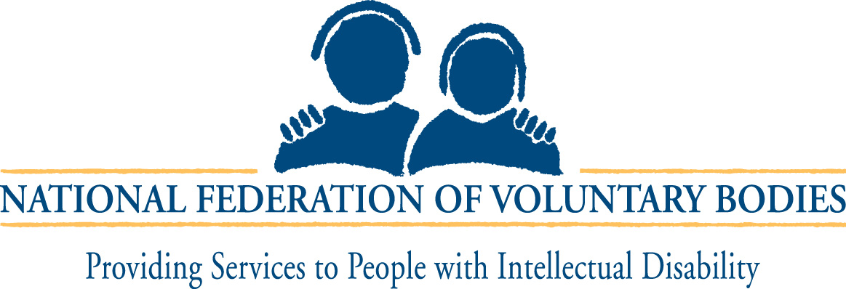

NATIONAL FEDERATION OF VOLUNTARY BODIES’ SUBMISSION
TO THE HEALTH SERVICE EXECUTIVE CORPORATE PLAN

- Enhancing the Partnership / Widening the Partnership:
  - Enhancing the Partnership / Widening the Partnership is generally viewed as a model of best practice in terms of a framework for partnership between the statutory and voluntary sectors.
  - While the document specifically relates to the provision of intellectual disability services we feel that its provisions would have relevance to other sectors also.
  - The document requires certain amendments to be agreed between the Health Service Executive (HSE) and the National Federation of Voluntary Bodies to take account of the revised structures.

2. Development of Services & Related Protocols:
- The multi annual investment programme (2005 – 2009), announced by Government in Budget 2005, provides a welcome opportunity to deal with waiting lists for services. The National Federation of Voluntary Bodies wishes to work in partnership with the HSE to ensure that there will be little or no waiting lists for services by the end of the investment programme. The National Federation of Voluntary Bodies is committed to ensuring that services and supports are provided in a person centred way, to a high standard of quality, which gives best value to funders, service providers, service users and their families.
- The 2005 services development protocols are not sufficiently flexible to provide for the needs of people with intellectual disability currently resident in long stay institutions. The National Federation of Voluntary Bodies & HSE will work collaboratively on a proposal to carry out in-depth research to establish the numbers of people with intellectual disability in this situation, to get an insight into their quality of life and to make recommendations about more appropriate service provision for them.

3. Harmon / Wolfe:
- As part of the discussions surrounding Enhancing the Partnership / Widening the Partnership, Government agreed to appoint independent experts to examine staffing levels within services to determine their adequacy and to make recommendations therein.
- This review, known as the Harmon / Wolfe process, remains incomplete some eight years after its initiation.
- It is important that the validity of the Harmon / Wolfe process be acknowledged by the HSE in terms of the provision of high quality services and its full implementation be achieved during the life of the Corporate Plan.

4. Core Funding Deficits:
- Projected year end (2005) core funding deficits in the intellectual disability sector is estimated at €30m.
- Against a backdrop of inadequate staffing levels as highlighted by the Harmon / Wolfe process a total of €24m has been taken out of the sector under the heading “Value for Money” cuts over the past 3 years. This is exacerbated by the situation whereby inadequate funding is provided to cover pay increases, increments, non pay inflation etc.
- This issue of core funding deficits needs to be addressed as a matter of urgency. When base funding levels have been established services and supports will be provided on the basis of business plans and service agreements to be agreed with the HSE and service providers.

