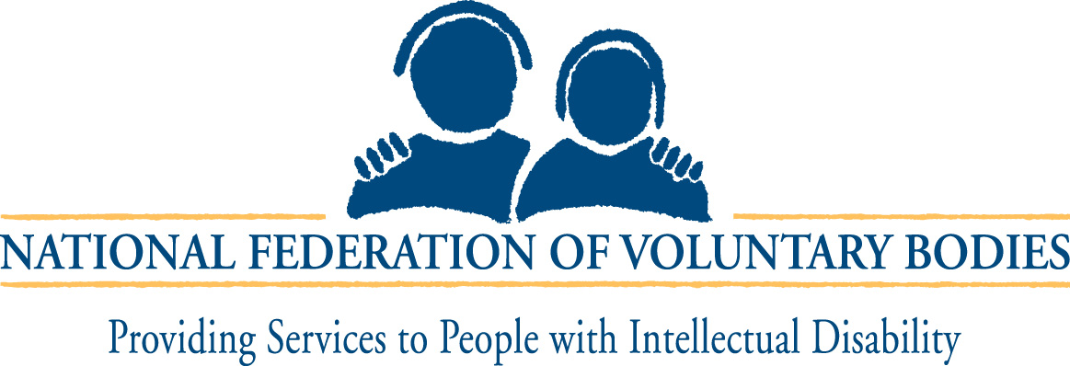

SUBMISSION BY NATIONAL FEDERATION OF VOLUNTARY BODIES
PROVIDING SERVICES TO PEOPLE WITH INTELLECTUAL DISABILITY
TO THE JOINT COMMITTEE ON JUSTICE, EQUALITY, DEFENCE AND WOMEN’S RIGHTS
ON THE DISABILITY BILL 2004

Introduction:
The National Federation is a national umbrella organisation for voluntary/non-statutory agencies who provide direct services to people with an intellectual disability in Ireland. The members of the National Federation are both voluntary and religious bodies with a clear vision rooted in the respect for and the dignity of the person. In all, our National Federation comprises some 62 affiliated organisations who between them account for in excess of 85% of this country’s direct service provision for people with an intellectual disability. Our members employ approximately 14,000 staff covering a wide range of professional disciplines providing services and supports to over 20,000 people.

See Appendix 1 for full list of all member organisations of the National Federation.

Mission:
The National Federation of Voluntary Bodies aims to promote the equalisation of opportunities for persons in the care of member organisations through the provision, maintenance and development of appropriate high quality services. The objectives are achieved through information sharing and through the development and promotion of codes of best practice. The National Federation also acts as a lobbying agent on a national and international basis and works in co-operation with advocacy organisations on behalf of persons with an intellectual disability.

Values:
The National Federation of Voluntary Bodies promotes and actively pursues four fundamental principles. People with an intellectual disability have:
- The right to a normal pattern of life within the community;
- The right to be treated as an individual with dignity and respect;
- The right to care and support in developing their maximum potential;
- The right to participate in the decision making process on issues affecting their lives.

We support the following internationally agreed statements:
- The United Nations Declaration on Human Rights and on the Rights of Intellectually Disabled Persons;
- The United Nations Standard Rules for the Equalisation of Opportunities for People with Disabilities;
- The United Nations Convention on the Rights of the Child.

Disability Bill 2004:
The National Federation of Voluntary Bodies is an active member of the Disability Legislation Consultative Group (DLCG) and as such has arranged comprehensive consultation amongst our membership throughout the country on all aspects of the Bill. Since the establishment of the DLCG, we have made numerous submissions arising out of our consultation process and have made significant input into the DLCG document “Equal Citizens” of which we are a co-signatory.

It is the view of the National Federation of Voluntary Bodies that while we are broadly supportive of the Disability Bill 2004, as currently drafted, it does give rise to significant concerns and we welcome the opportunity to work with Government to address these issues which are as follows:

- Definition:
In our view the definition of Disability contained in the Bill is too narrow and restrictive. We have particular concerns about the terms “substantial restriction” and “enduring”. We are also concerned that the definition as currently drafted excludes episodic conditions and early intervention needs. With regard to the latter, for example, it is our experience that many parents present to our early intervention services with young children with query autistic spectrum or intellectual disabling conditions. Our concern is that these services will be denied to them in the absence of a definitive diagnosis, which accords with the definition outlined in the Bill.

- Assessment of Need:
The Bill must provide a clear legal entitlement to an independent assessment of need.

- Progressivity:
The Bill must provide for an individual’s right to progressivity on their unmet needs identified in their independent assessment reports. It is imperative also that progress be made in terms of meeting the changing needs of people already availing of services such as people with intellectual disability in long term residential care.

In addition, there should also be a record of “national unmet needs” i.e. the variance between the aggregated assessment reports and the services actually provided. This should be the form of an Annual Report which will be an invaluable tool in terms of tracking unmet needs and identifying priorities for services development.

- Resourcing:
The Bill must provide for a clear ring-fencing of disability specific resources. Section 5 of the Bill is, in our view, unnecessarily complex and ambiguous and requires re-drafting to clearly state that funding voted for disability services development is ring-fenced.

- Complaints & Appeals:
The National Federation of Voluntary Bodies is concerned at the very complex system of complaints and appeals, which the Bill proposes. It needs to be simplified, more easily accessible and truly independent. We recommend that an independent complaints system should be established under the Office of the Ombudsman, with powers and resources also covering the private sector, as outlined in the DLCG document “Equal Citizens”. Also, the appeals system needs to be independent of the Department of Health & Children and needs to be sited in another appropriate Government Department.

- Monitoring & Accountability:
The Bill must provide for a clear statutory duty on all government departments and public bodies to include people with disabilities in their plans and services with appropriate monitoring and accountability. The task of monitoring the legislation should rest with the Equality Authority. Sufficient resources and powers should be assigned to the Equality Authority to enable it to carry out this role.

- Review Procedures:
Given the potentially ground breaking nature of the Bill and in the light of European and International commitments the legislation should be reviewed within two years of operation, or three years of its enactment, whichever is the soonest.

- Public Services:
Public services should include all public services provided in the public system by statutory or non statutory entities. Also the sectoral plans as provided for in the Bill need to take account of the wider needs of people with disabilities. In this regard, for example, it is somewhat surprising and disappointing for us to note that the Department of Environment and Local Government’s sectoral plan has not addressed the housing needs of people with disabilities.

- Equal Status Act:
We are actively seeking clarification on the impact of the Disability Bill 2004 on Section 14 of the Equal Status Act.

APPENDIX 1 –

MEMBER ORGANISATIONS OF THE NATIONAL FEDERATION

Affiliates:
- Ard Aoibhinn Centre, Wexford;
- BEAM Services, Carlow;
- Association of Parents & Friends of the Mentally Handicapped, Carrickmacross Co. Ltd;
- Brothers of Charity Services;
- Camphill Communities of Ireland;
- Cheeverstown House, Dublin;
- Children’s Sunshine Home, Dublin;
- Clones Branch of the Mentally Handicapped, Monaghan;
- County Wexford Community Workshop, Enniscorthy;
- County Wexford Community Workshop, New Ross;
- Co. Wicklow Association;
- CoAction West Cork;
- COPE Foundation, Cork;
- Dara Residential Services Ltd., Kildare;
- Daughters of Charity Services;
- Delta Centre, Carlow;
- Drumlin House, Cavan;
- Galway County Association;
- The Holy Angels, Carlow;
- Hospitaller Order of St. John of God;
- Irish Sisters of Charity;
- K.A.R.E., Kildare;
- K.A.S.M.H.A., Kilkenny;
- Kerry Parents & Friends Association;
- L’Arche Ireland;
- Little Angels Association, Letterkenny, County Donegal;
- Meath Association for the Mentally Handicapped Ltd.;
- MIDWAY (formally Meath Sheltered Workshop);
- Moore Haven Centre, Tipperary;
- North West Parents & Friends Association, Sligo;
- Order of Malta Enterprises;
- Peacehaven, Co. Wicklow;
- Peamount Hospital, Dublin;
- Prosper Fingal, Dublin;
- RehabCare;
- Sisters of La Sagesse, Sligo;
- Sisters of the Bon Sauveur, Waterford;
- SOS Kilkenny Ltd.;
- Sisters of Charity of Jesus & Mary;
- St. Aidan’s, Gorey, County Wexford;
- St. Anne’s Service, Roscrea, County Tipperary;
- St. Christopher’s Services, Longford;
- St. Cronan’s Association, Roscrea, County Tipperary;
- St. Hilda’s Service, Athlone, County Westmeath;
- St. Joseph’s Foundation, Charleville, Co. Cork;
- St. Mary of the Angels, Kerry;
- St. Michael’s House, Dublin;
- Stewart’s Hospital, Dublin;
- Sunbeam House Services, Bray, County Wicklow;
- Tipperary Association for Special Needs;
- Walkinstown Association, Dublin;
- Waterford Association for Mental Handicap;
- Western Care Association, Mayo;
- Windmill Therapeutics Training Unit, Wexford.

