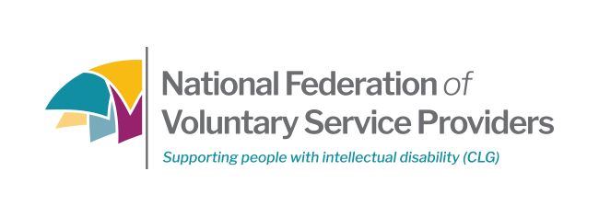
COMPLAINTS FORM

This form may be used to make a complaint about services provided by the National Federation of Voluntary Service Providers (NFVSP). Complaints may also be submitted in person, with an assistant, by phone, e-mail or by someone acting on your behalf.


If you need information in a different format (eg Braille, large print etc)
or if you have other specific needs, please let us know.
Full contact details are listed at the bottom of this form.

This form should be read in conjunction with National Federation of Voluntary Service Providers Complaints Procedure available from the NFVSP office.

First, please give us your details
Surname |  | title
First name(s)
Address for
writing to you
Daytime phone
Home phone
Mobile
Email

If you are making this complaint on behalf of a business, charity or trust please fill in these details

Organisation Name
Address
Phone
Email

 | day | month |  | year
- When did the alleged incident take place?
- Where did it take place?
- Who was involved?
- Was any effort made to resolve this informally? YES  - If |  | NO
- If yes, please set out details:

Any other details that you think will help us understand your complaint

Please tell us what your complaint is about

Sign here If you’re signing on behalf of an organisation, please give your job title.

__________________ _____ ___________
Signature Date Job Title

Please send to…
Complaints Officer
National Federation of Voluntary Service Providers
Oranmore Business Park, Oranmore, Galway
Tel : 091 792316 Email : info@fedvol.ie

